**Audio Equalizer**

**[DSP Final Project]**

Prepared by: Mohamad Tarek

ID: 4774

# Introduction

## Overview

Audio Equalizer is a **GUI based** sound editing tool to manipulate different frequency components of an input (.wav) file.

# Requirements Specifications

This software was made by MATLAB R2019a App Designer.

There are 2 provided versions:

* “AudioEqualizer.mlapp”: needs MATLAB R2018a or higher to open
* “AudioEqualizer2016.mlapp”: needs MATLAB R2016b or higher to open

# Design Aspects

## Graphical User Interface

The program provides a smooth, user friendly interface to read an input sound file of (.wav) format then offers various options to edit the sound depending on gains provided by the user for each frequency band.

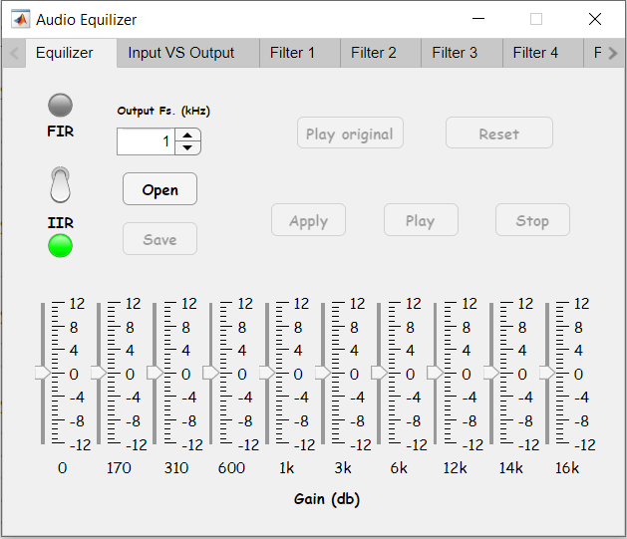

The GUI is tab-based including 12 tabs:

* 1 for the equalizer settings
* 1 for comparing Input & output signals in both time and frequency domains
* 10 tabs one for each filter including plots for:

1. Gain
2. Phase
3. Impulse response
4. Step response
5. Filtered output in time domain
6. Filtered output in frequency domain

After editing, the user can save the output sound signal as a (.wav) sound file in the desired directory.

## Assumptions & User Requirements

The user has to provide:

* The sound file to edit
* The output sampling frequency
* Gain for each frequency
* The type of the required filtration process (IIR / FIR)

# Sample runs

**IIR filtration**

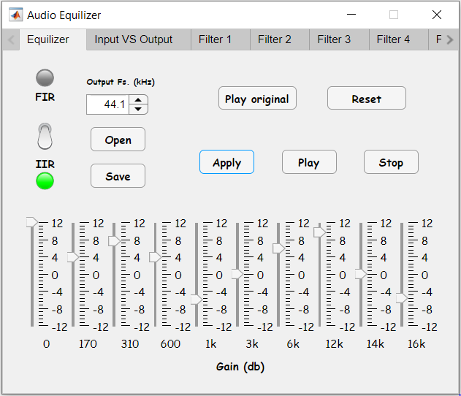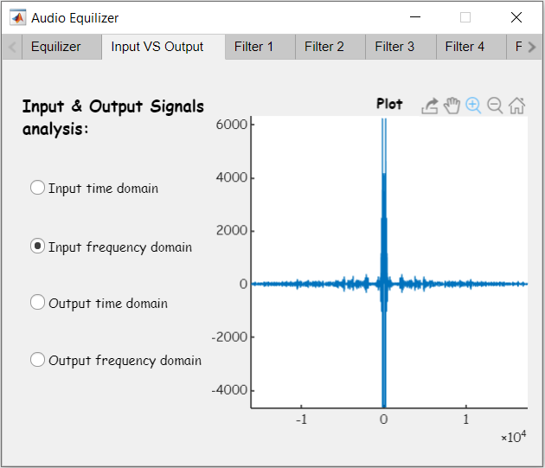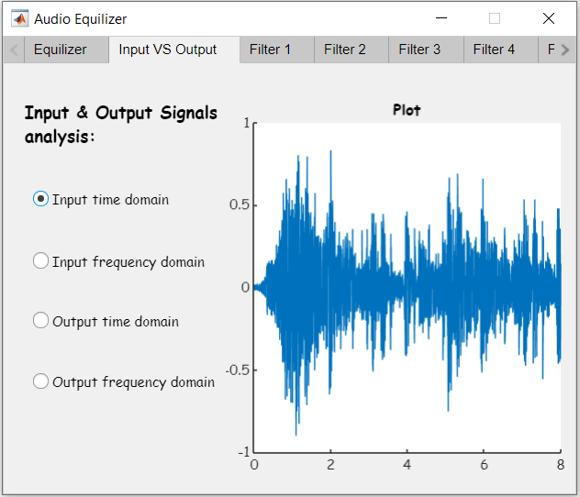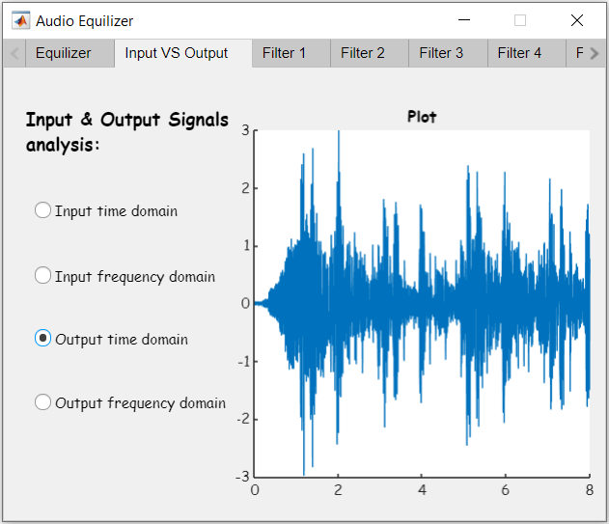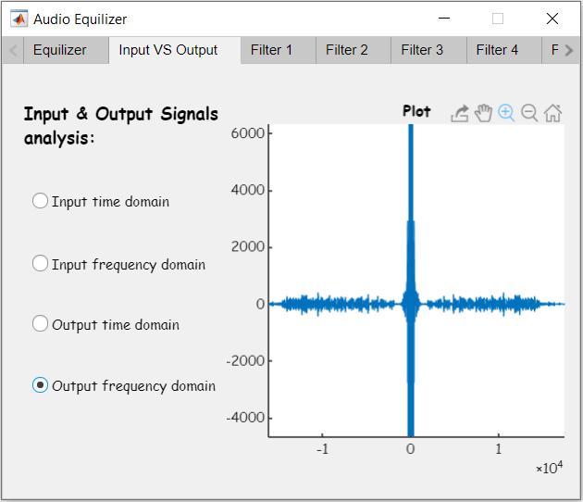

FIR filtration

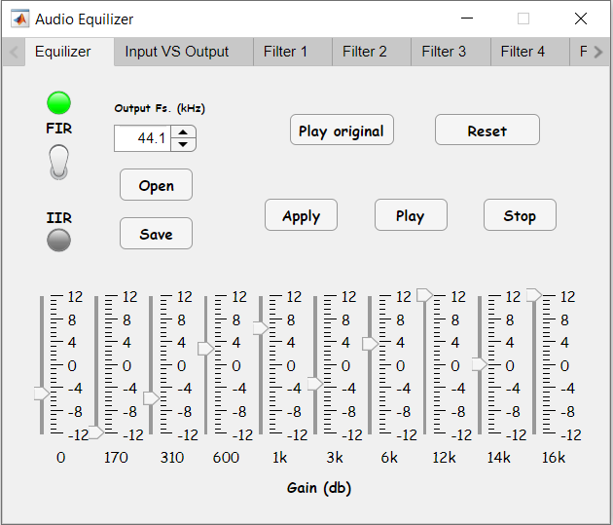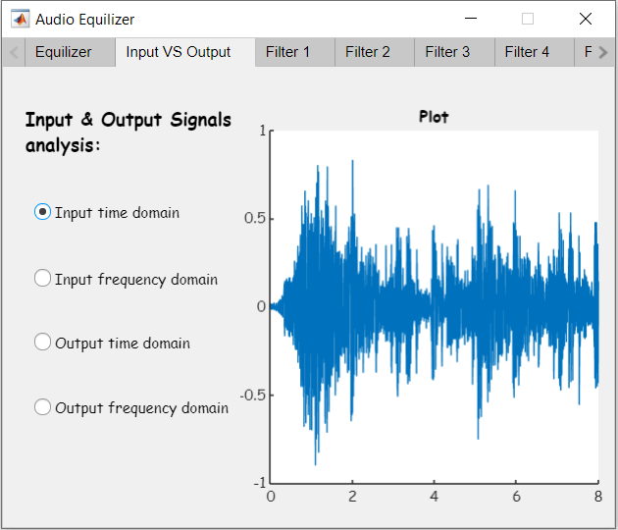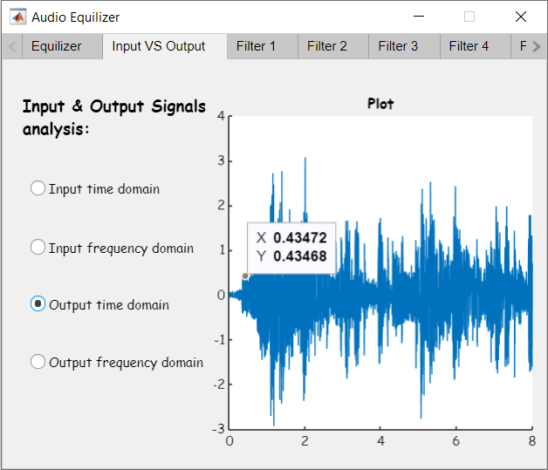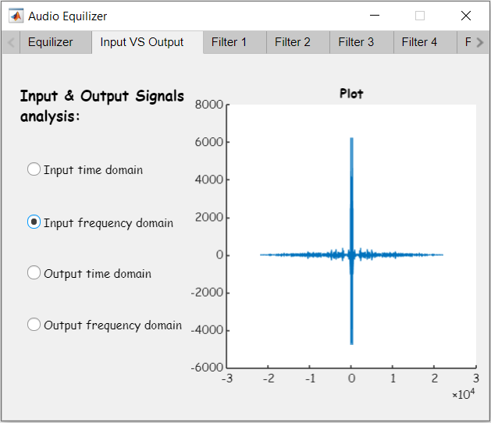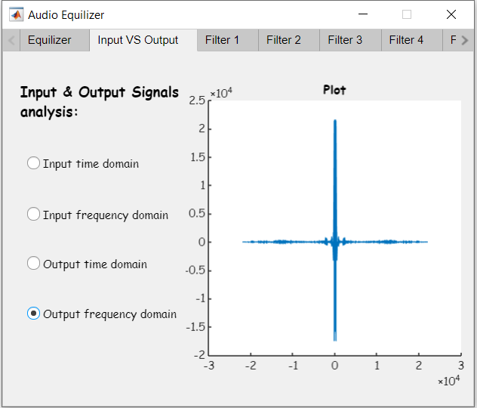

Doubling sample frequency

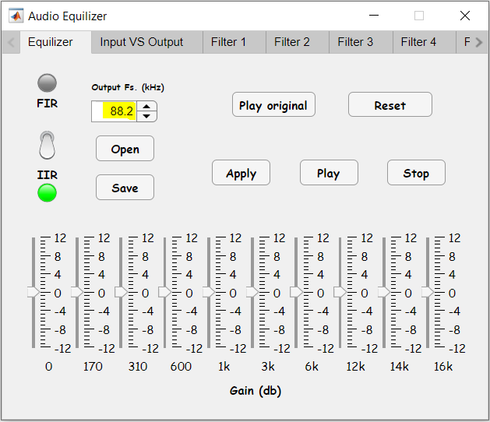

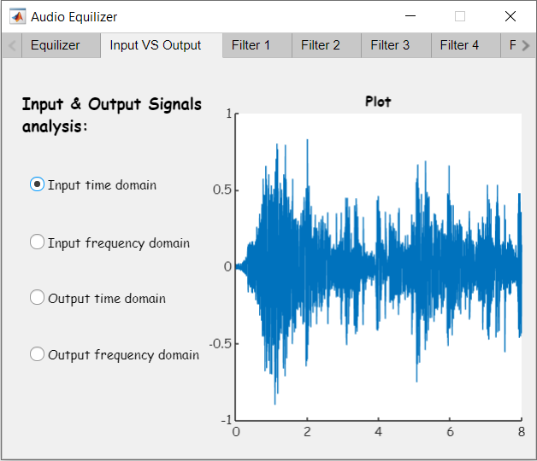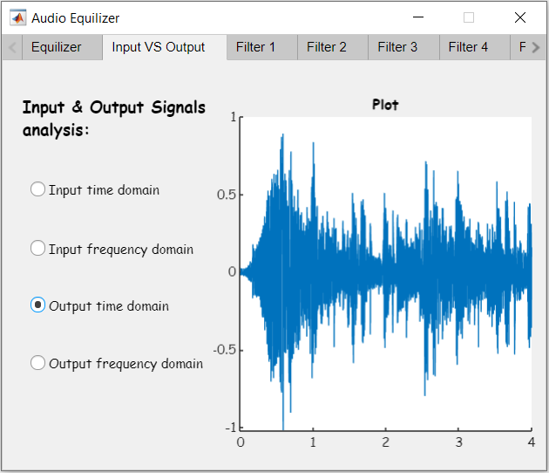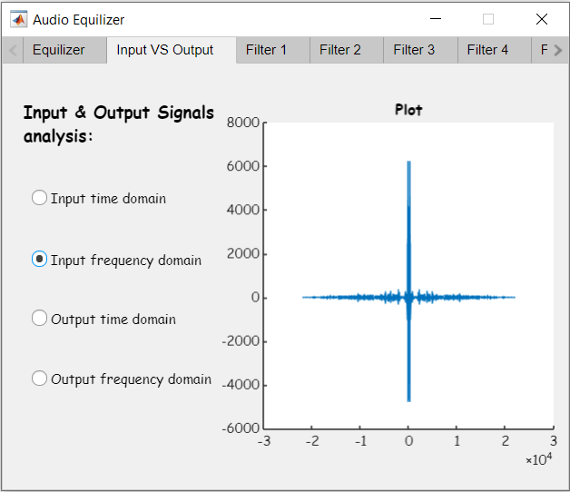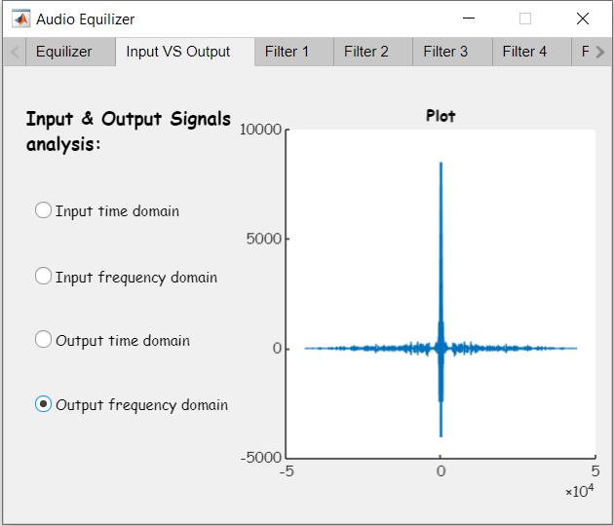

Half sampling frequency

